## Adding and selecting intersection elements

Note the 4 icons at the top of the Intersection Editor panel - these can be used to switch between the available editor modes:

* Road properties - adding and editing incoming roads,
* Road extensions - road corners and turn lanes,
* Markings - lane markers, stop lines and flush medians,
* Symbols - crosswalks and lane symbols.

To add an intersection element, switch to the required category and click one of the add [+] buttons in the panel. This will decorate the intersection with additional [+] buttons showing places where this type of element can be added. The sample below shows the process for adding a turn lane:

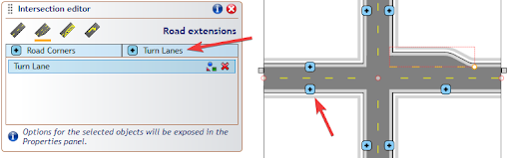

Adding_intersection_elements

Once an intersection element is added, it appears on the elements list in its category. You can select an intersection element directly from the list, or by holding the Ctrl+Alt keys and clicking on the required element of the intersection object. The selected element gets highlighted with a red outline. TIP: to select more than one element hold the Ctrl key when selecting from the editor list, or Ctrl+Alt+Shift when clicking on the intersection object.

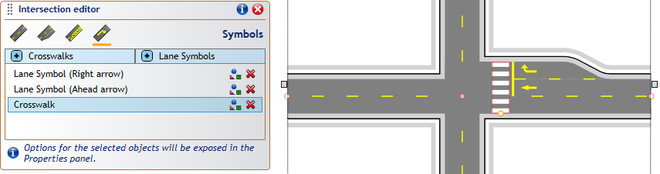

Selecting_intersection_elements